Historical Overview
Lackawanna County Courthouse

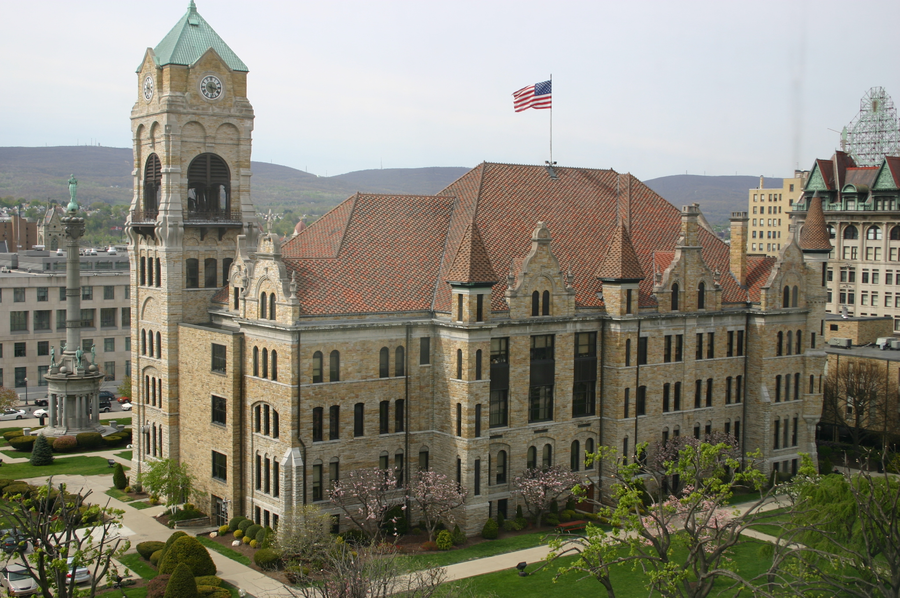

The Lackawanna County Courthouse on Courthouse Square is located at North Washington Avenue and Adams Avenue between Spruce Street and Linden Street. It was built in 1881-84, and remodeled in 1896. The need for a County courthouse arose in 1878 when Lackawanna County was created from the northern portion of Luzerne County. Erection commenced after the announcement for the structure was awarded to Isaac G. Perry of Binghamton, New York.

The land on which the courthouse stands originally was a cranberry bog called the “Lily Pond” which the children of Scranton forefathers used for ice skating. As part of the land holdings of the Lackawanna Iron and Coal Company, it was donated to the new county. Before the building could be constructed, the swamp was filled by the construction of a tunnel from the Iron Furnaces which passed under the Scranton Estate. Dirt and slag from the Iron Furnaces was transported to the site by mine cars which ran on rails through the tunnel.

The architectural style of the courthouse is Victorian Gothic with Romanesque details. The building, like all of Scranton’s early public structures, is of locally-quarried West Mountain stone, trimmed with Onondaga limestone construction. Gothic details included tall corner towers, carved stone details and ornamental bultresses. Romanesque details included round-arched windows and tower openings.

In 1896, local architect R. Taylor Lacey designed the building’s third floor, adding eclectic stylistic influences such as steeply pitched hipped tile roof, wall dormers with scrolled flemish parapets topped by broken pediments and urns, a dentillated cornice and pyramidal-roofed towers.

The Lackawanna County Courthouse gained national attention in 1902 for its role as the meeting site for the Anthracite Coal Strike Commission’s sessions in Scranton. The Commission appointed by President Theodore Roosevelt-met in the Superior Courtroom (now courtroom #3) to hear testimony. Labor leader John Mitchell-represented by noted labor and criminal attorney Clarence Darrow-testified not as president of the United Mine Workers, but as “the representative of mine workers.” The Anthracite Coal Strike Commission is nationally significant because of the unprecedented creation of such a body by a U.S. President. This was the first time in American history that there was an even-handed, non-violent federal intervention between labor and capital.

Alterations to the Courthouse building have included the re-design of the clock tower (1929) and the addition of a two story rectangular wing (1964).

The building is listed on the National Register of Historic Places.

*Information was provided by the Lackawanna Historical Society.

Fact Sheet: Lackawanna County Courthouse

Build in 1881-1884

Ground broken April 23, 1881

Cornerstone laid May 25, 1882

Architect- Isaac G. Perry, Binghamton, N.Y.

Property donated by Lackawanna Iron & Coal Company

Contractor- John Smith, Ithaca, NY

Build with native West Mountain Stone trimmed with Onondaga limestone

Occupies a 4.7-acre lot bounded by Washington Avenue, Linden Street, Adams Avenue and Spruce Street in downtown, Scranton.

The building is a three-and-one-half-story, rectangular plan, masonry building.

It measurements are 100 by 140 feet with a raised basement, hipped roof, and a five-story clock tower.

